STRAIGHTENING THE PATH 5K SPONSORSHIP LEVELS
(Fundraiser for Scoliosis- proceeds after all race expenses will go to the National Scoliosis Foundation a non-profit organization)

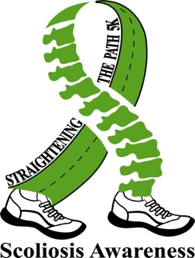
Reasons why sponsoring this event will benefit your business
-Brand visibility
-Opportunity to network in a large diverse event
-Supporting a cause to help children, adults and health-care
providers to understand the need of early detection

DIAMOND SPONSOR ($3,000+)
- Business logo on back of t-shirts
- Business logo and link to your website on registration site (*see below) and our website
- Individual banner at entrance of race site
- Logo added to banner with other sponsors (under Diamond)
- Logo added to banner at water station on course
- Sponsor sign for recognition at your place of business
- Business name added to sponsor list sign placed at the packet pick up table
- Booth /table at event with 2 chairs (if desire)
- Opportunity to speak at event (if desire)
- 10 waived entry fees to event, 10 t-shirts with swag bags
- Recognition on social media (Facebook & Instagram) and our website
- Verbal recognition during day of event
- Option to contribute giveaways to runner’s swag bags
GOLD SPONSOR ($1,000)
- Business logo on back of t-shirts
- Business logo and link to your website on registration site (*see below) and our website
- Logo added to banner with other sponsors (under Gold)
- Business name added to sponsor list sign placed at the packet pick up table
- Booth/table at event with 2 chairs (if you desire)
- 5 waived entry fees to the event, 5 t-shirts with swag bags
- Recognized on social media (Facebook & Instagram) and our website
- Verbal recognition during day of event
- Option to contribute giveaways to runner’s swag bags
SILVER SPONSOR ($500)
- Business name on back of t-shirts
- Business name added to sponsor list sign placed at the packet pick up table
- Logo added to banner with other sponsors (under Silver)
- 2 waived entry fees to the event, 2 t-shirts with swag bags
- Recognized on social media (Facebook & Instagram) and our website
- Booth /table at event with 2 chairs (if desire)
- Option to contribute giveaways to runner’s swag bags
BRONZE SPONSOR ($250)
- Business name added to sponsor list sign placed at the packet pick up table
- Logo added to banner with other sponsors (under Bronze)
- 1 waived entry fee to the event, a t-shirt with swag bag
- Recognized on social media (Facebook & Instagram) and our website
- Option to contribute giveaways to runner’s swag bags
*Your logo and website will be seen when participants register, anyone that visits the site, looks for sponsorship opportunities or signs up to volunteer for our event at www.runnc.com/event/171346 As the event gets closer, the event is repeatedly shared in their bi-weekly “Upcoming Races” emailed to over 20,000 runners in the area.
If you’re interested in becoming a huge part of this fundraising event and being a sponsor, please email us at straighteningthepath@gmail.com for more information.

