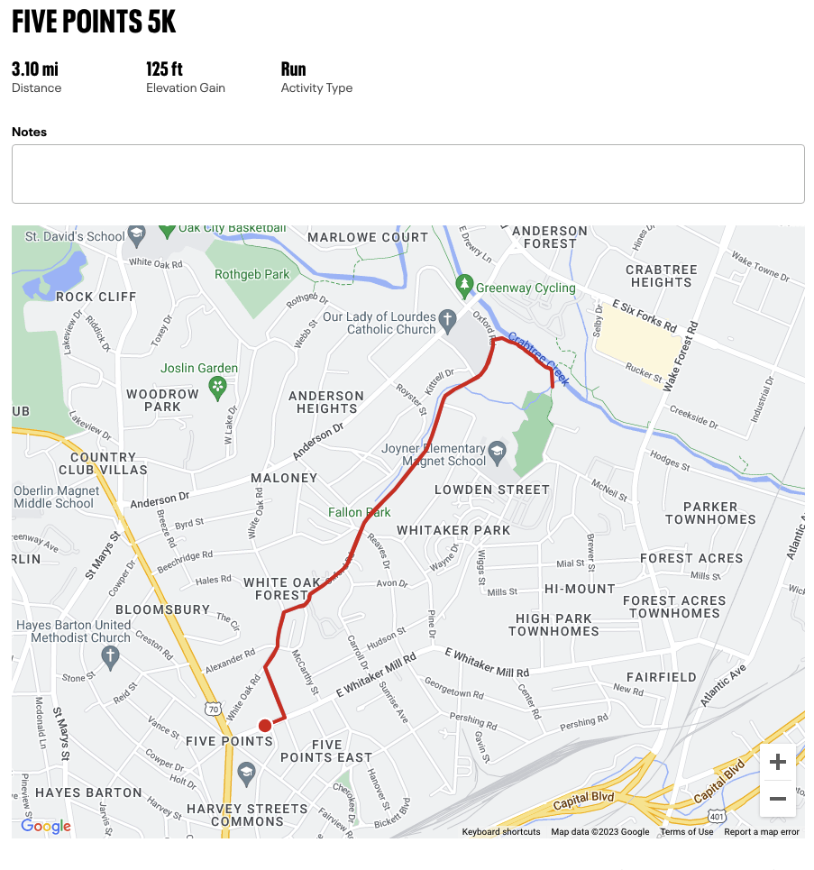

- Start at HBBC
- Left on E. Whitaker Mill Rd.
- Left on Sunset Dr.
- Right on White Oak Rd.
- Right on Oxford Rd.
- Right onto Greenway along Crabtree Creek
- Turn around, run course in reverse.
- End at HBBC

